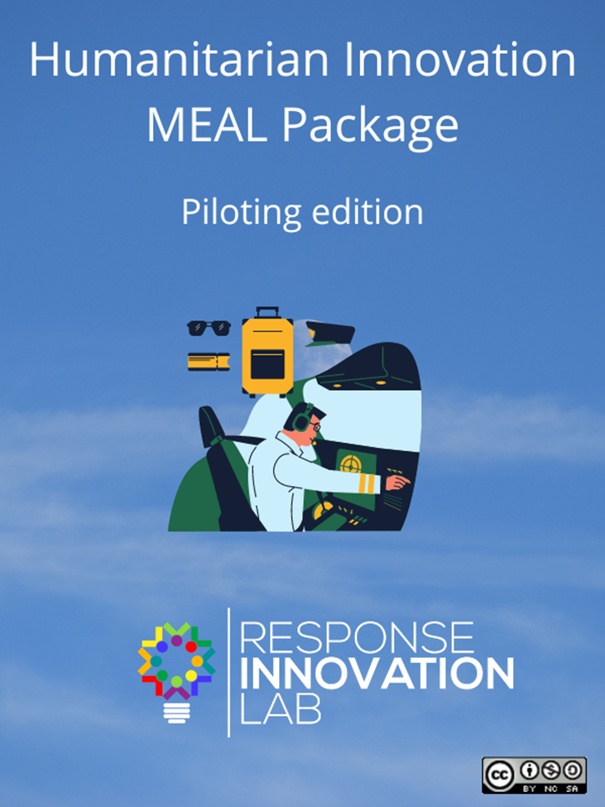

**Innovation Evidence Generation Package – Pilot edition**

Introduction

This set of tools includes simplified MEAL guidance to be applied by innovators that are looking to generate quality evidence for a pilot project. In particular, this package targets users who are willing to invest a reasonable amount of time to ensure that their work yields usable information, both for their internal design and implementation planning purposes as well as for the promotion of their solution to external stakeholders. You can find a more comprehensive set of tools, including guidance on ideation and prototyping by checking out the full RIL Innovation Evidence Toolkit here: <https://www.responseinnovationlab.com/innovation-evidence-toolkit>

At Response Innovation Lab, we define innovation as a deliberate attempt to improve a system or solve a challenge through the introduction of new ideas, tools or procedures. This toolkit can be used for all types of innovations, from fully digital to technology-enabled to wholly analog products, services or approaches.

This Piloting Evidence Package includes the following documents/tools:

* Simplified Theory of Change for Innovation: This is a planning tool that will help you develop a simple chain of results starting with what your innovation provides in terms of activities/features all the way to the ultimate impact it may have on individuals, communities and systems. It also includes a simple logic framework template to help you match indicators to your objectives. If you have developed a full Theory of Change or Logic and/or MEAL framework, you may use these instead.



* The Qualitative Feedback Guidance Tool: This tool will help you collect and analyze feedback from users, beneficiaries and “customers” of you solution. Its results should help you identify improvements to make in the design of your solution and/or its roll-out.



* The Pilot Data Management Tool: This form guides you in identifying the kind of data to collect to make certain that you have adequate information on the uptake and performance of your solution. Since innovation pilots test both the design and implementation of a product/service/approach, it is vitally important that you collect a range of qualitative and quantitative indicators that will tell you whether people, communities and/or facilities are adopting your solution and whether the changes that its introduction create match your expectations.



* The Humanitarian Accountability and Ethics Checklist: This self-administered checklist will help you identify gaps and potential risks in your engagement with direct users and the communities taking part in your pilot project.



* Pivot Diary: This standard RIL form is a very basic template in which to record the feedback you have received on your innovation as you test it, the changes that you have made to the design or implementation and the results of those changes.



* The Innovation Story Tool: This simple form will help you create a narrative of your innovation journey by documenting how your experiences and those of your users have led to changes in the design or implementation strategy of your solution.



* The Value for Money / Return on Investment Tool: This tool provides step-by-step instructions on how to collect and use implementation data and budget information to develop a simple rationale for investing into your solution.



* The Innovation Toolkit Master Worksheets document: This Excel document contains all of the templates (except the Innovation Story Tool and Simplified Theory of Change for Innovation) mentioned in the documents above. Please use it to record your inputs.



**Instructions**

**Preliminary question – Piloting or Scaling**

Before proceeding with these instructions and the tools that follow, it is important to make certain that you are at the appropriate stage on your innovation journey by answering the following questions:

* Has a full version of your innovation been used in real-world conditions for a full cycle of programming?
* Have the results from one or more of these tests demonstrated conclusively the effect of your solution to users and beneficiaries?
* Has the design of your solution evolved through real-world testing and is now considered fully functional?
* Is your innovation being integrated into an organization’s “mainstream” programming?
* Do you deem your innovation ready to be applied in new locations, new sectors or for new groups of users?

If you answered yes to two or more of these questions, your innovation is likely ready to move beyond the pilot phase and into the scaling category.

If you answered yes to only one of the questions above, you may or may not be at the scaling phase and are free to chose which toolkit is a better fit.

If you answered no to all of the questions above, you are definitely in the right place – please continue reading!

**Step One – Planning for monitoring, evaluation and learning**

*When?:* As soon as possible, during pilot design and NOT after implementation has begun.

*By whom?:* All parties implementing the pilot

*Tools to use:*  Simplified Theory of Change for Innovation, Pilot Data Management Tool, VfM/ROI Tool

*How?:*

1. Schedule a special meeting to discuss the pilot’s MEAL plan with all parties taking part in the pilot’s organization and implementation;
2. Disseminate these instructions and the tools of the Evidence Generation Package to all parties for review;
3. If you have not done so already, fill in the Simplified Theory of Change for Innovation, preferably during a collaborative work session. Once you have completed the tool, think about how far down the chain of results you would like your pilot project to reach (i.e., will you be testing largely to see if you are able to achieve your expected outputs or will you be looking to see if you can measure intermediate results or outcomes?).

Refer to the Simplified Theory of Change for Innovation and the Pilot Data Management Tool when designing your pilot to make certain that its scale, scope and duration will be able to provide you with the information you need.

**Step Two – customizing**

*When?:* During the MEAL planning meeting

*By whom?:* All parties implementing the pilot

*Tools to use:* Simplified Theory of Change of Innovation Logframe; Pilot Data Management Tool, Qualitative Feedback Guidance Tool, VfM/ROI tool (optional)

*How?:*

1. Begin by agreeing what specific results the project expects to achieve, that is what changes will be experienced by the targeted beneficiaries by the time the implementation concludes. These will need to be consistent with your Theory of Change and with the scale, scope and duration of your project.
2. Fill in the Pilot Data Management Form using the instructions provided there.

When filling the Uptake Indicators table, please try to make as few modifications as possible to the indicators themselves and focus on setting realistic targets for each.

Next, please make certain that you include output -level indicators for all of the features of your solution that you are looking to test.

It is possible that some of the data will need to be gathered directly from the beneficiaries through customized surveys. If that is the case, you will need to decide on what questions to be asked. RIL guidance on how to design surveys can be found [here](https://www.responseinnovationlab.com/s/DATA-Survey.doc).

Please make sure to select indicators that are S.M.A.R.T. (Specific, Measurable, Available, Responsive and Timely). The data management form has links to further instructions on indicator selection. You will also need to ensure that collecting this data will be possible within your timeline, budget, access and staff capacity. It is better to have a few reliable indicators than a high volume of flawed data.

1. Now that the Pilot Data Management Tool is filled, go on to review the Qualitative Feedback Guidance Tool to see which questionnaires apply to your pilot and if there needs to be any changes to the questions provided in the standard template. Make sure that these questions help you answer questions you may have on the use, uptake and impact of your innovation, as well as on how the pilot was implemented. It is assumed that your will have already consulted your users in the design of your solution regarding their living conditions, educational levels, attitudes, priorities and other elements relevant to the uptake of your innovation. Even if you have, it is always a good idea to refresh that data through additional questions that can be added to the Qualitative Feedback Guidance Tool and the questionnaires you will use to interact with stakeholders.
2. If you plan on using it, you will also need to review the Vfm/ROI Tool here to see if the indicator(s) you need to measure returns will be included in your Data Management Tool. If they are not, you may want to include them there.

**Step Three –Baseline data collection and initial consultations**

*When?:* Immediately after finalizing the MEAL tools and before the start of implementation

*By whom?:* The pilot implementer(s)

*Tools to use:*  Pilot Data Management Tool, Qualitative Feedback Guidance Tool, Humanitarian Accountability and Ethics Checklist, Pivot Diary

*How?:* If you are using indicators that require comparing changes to a baseline (i.e. when that baseline is not zero), you will need to establish what the current state of these indicators are. When these are based on survey results, a pre-implementation survey will need to be administered. For indicators collected by external actors, the latest data will need to be obtained. Generally, output and uptake indicators will not require a baseline as it will be assumed their value will start at nil, though if your pilot is building on a previous project, you may have a baseline to work with.

Users and beneficiaries will need to be consulted before the start of the project to inform them about the innovation and how it will be implemented, as well as collect initial feedback on the design of these. Instructions on how to conduct [surveys](https://www.responseinnovationlab.com/s/DATA-Survey.doc), [focus group discussions (FGD)](https://www.responseinnovationlab.com/s/DATA-Focus-Group.doc) or [key informant interviews](https://www.responseinnovationlab.com/s/DATA-Interview.doc) (KII) can be found by clicking the relevant link(s). This initial round of feedback may generate some inputs that will alter your design or implementation plans. If that is the case, please record your pivots in the Pivot Diary.

Once you have engaged with the pilot’s users and communities, you will need to go through the Humanitarian Accountability and Ethics checklist to see if you identify any potential issues before moving on to implementation.

**Step Four – Monitoring during implementation**

*When?:* Throughout the implementation period

*By whom?:* The pilot implementer(s)

*Tools to use:* Pilot Data Management Tool, Qualitative Feedback Guidance Tool, Humanitarian Accountability and Ethics Checklist, Pivot Diary

*How?:* During the implementation phase of the project, the team in charge of the pilot should routinely consult users and beneficiaries, through formal (surveys, FGD, KII) or informal means. Feedback from these sessions leading to changes in the design or implementation of the innovation should be entered into the Pivot Diary.

Uptake and Output indicators should also be monitored routinely to see how they are progressing and if they appear reliable and obtainable. Data should be regularly entered into the Pilot Data Management template and analyzed (at least on a monthly basis).

Humanitarian Accountability and Ethics Checklist should also be reviewed at least monthly and updated with any information or incidents recorded. Changes made through this process should be recorded in the Pivot Diary.

**Step Five – Post-Pilot Assessment**

*When?:* Immediately following the end of the pilot implementation

*By whom?:* The pilot implementer(s)

*Tools to use:* All of them.

*How?:*

1. Collect the data needed to fill the Pilot Data Management Tool;
2. Organize final beneficiary and user consultations to capture indicators for the Data Management Tool, the Pilot Qualitative Feedback Guidance Tool and, if needed, the VfM/ROI Tool.
3. Review the Pivot Diary and use the data from the forms mentioned above to fill the Pilot Innovation Story tool;