Business Pitching: Recoverable Grants for Innovative Child Health-Centered Businesses
Location: Golden Tulip Hotel
Date: Friday, November 8, 2023
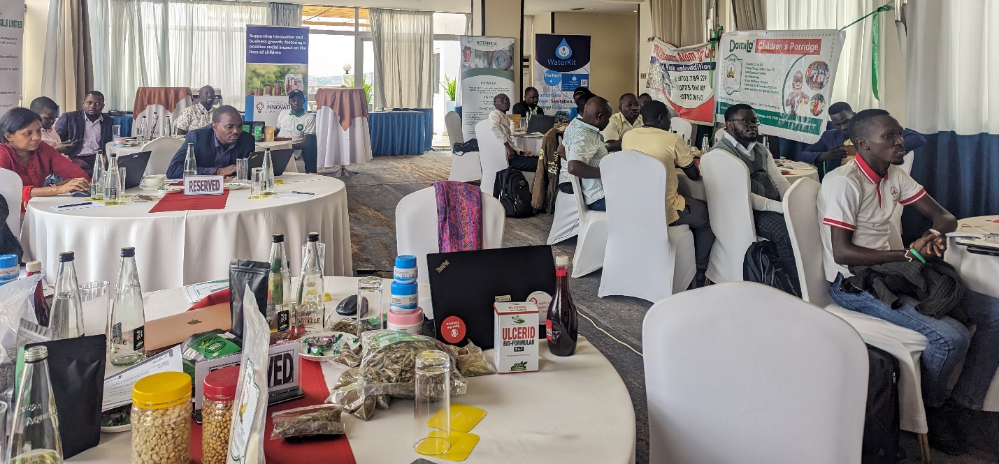
Photo: Recoverable grant business pitch attendees. Friday, December 8, 2023. Photo credit: U-RIL
Introduction
The Uganda Response Innovation Lab (U-RIL), hosted by Save the Children, received funding from Kumwe Hub to provide recoverable grants, focusing on supporting businesses in health and nutrition for children. The goal is to facilitate business growth, fostering a positive social impact on the lives of children and communities. In this first round, U-RIL made a call for applications, received 41 applications, out of which 40 met the criteria. These underwent a rigorous review, and 10 were shortlisted for pitching.
Successful applicants will receive recoverable grants ranging from US$5,000 to US$10,000 and a tailored package of business support services that include technical support, business advisory, and mentoring from world-class business experts.
The business pitch on Friday, December 8, 2023 marked the final stage of the selection process. Businesses that reached this stage had successfully navigated earlier stages, including screening and shortlisting. During the pitch sessions, entrepreneurs presented their business models to the selection panel of five judges; Daniel Wasswa-United Social Ventures, Grace Nakibaala-Response Innovation Lab (RIL), Vanessa Mwangale-RIL, Racheal Auma-Save the Children and Innocent Mallya- Innovation Village.
Opening remarks
U-RIL Program Manager Grace Nakibaala welcomed participants. She gave a brief overview of the Response Innovation Lab as a humanitarian innovation support organization focusing on humanitarian cross-sectoral learning, digital solutions, and innovation with four key components: mapping and convening actors, matchmaking and brokering partnerships, supporting and scaling innovation, and generating and sharing evidence.
She introduced the judges and wished all the pitchers the best of luck.

Pitching session
Applicants pitched in alphabetical order.
- Botanica Repellent Co. Ltd
Photo: Botanica Repellent's Patience Baraka delivers a business pitch. Friday, December 8, 2023. Photo credit: U-RIL
Patient Baraka founded Botanica Repellent Company in Uganda's Nakivale Refugee Settlement in 2020. This decision was inspired by his challenges as a new refugee from the Democratic Republic of Congo in 2016 when his little sister suffered from malaria and being an adolescent himself, he couldn’t do much to help. The company's mission is to address malaria infections in children under 5.
Botanica focuses on producing an eco-friendly, natural mosquito-repellent body cream certified by the National Drug Authority. Beyond prevention, the product serves a dual purpose by acting as a skin moisturizer. The company's market presence extends to over 700 users monthly.
Funding ask: $8,500
Allocation: Renovating the production facilities and buying machinery to increase production

Questions from judges
Q: What alternative products are available in the market?
A: Available alternatives include insect sprays and mosquito nets. However, most insect sprays are toxic, and mosquito nets are not mobile, so they can only be used during sleep. Botanica can be applied to the skin at any time, uses natural resources and is not harmful.
Q: How has the product improved the health and nutrition of children?
A: Once a child has malaria, they lose appetite and can become malnourished. However, Botanica prevents malaria and thus prevents malnutrition.
Q: What’s the success rate?
A: We have distributed the product to over 600 families. We provide gift bags to communities using the revenue from selling the product. In November, we gave gift bags to over 200 families. In terms of market, we have reached over 1,000 customers.
Q: Is it certified? Have you been able to break even?
A: We have successfully been certified by the National Drug Authority after six months of trial. We are awaiting UNBS approval. We broke even last year.
Q: What’s the current production capacity and by how much will machinery increase it?
A: We are still doing things manually. The machines can produce more than 200 tins, which is four times as much as the current capacity of 50 tins every two hours. It will also increase employment opportunities as we expand our market.

- Bugiri Young Rice Farmers Cooperative Ltd
Photo: Bugiri Young Rice Farmers' Kenneth Mwanja and Joseph Bota make a business pitch. Friday, December 1, 2023. Photo credit: U-RIL

Established in 2016 and formally registered in 2020, Bugiri Young Rice Farmers Cooperative Society Limited (BUFACO) is a multipurpose cooperative society with a vision to increase household income through value chain growth, specifically targeting women and young farmers. The cooperative operates in Bugiri District, Uganda, contributing to rice production, farmer sensitization, and the supply of inputs to enhance agricultural activities.
BUFACO plays a vital role in supporting its 569 members, primarily engaged in rice cultivation. The cooperative also previously ran a climate-smart program and collaborates with partners, including the United States Africa Development Foundation (Closed), to implement initiatives that enhance the resilience of farmers to climate change.
Recognizing the malnutrition of children in Bugiri district, BUFACO’s approach involves adding value to main food crops, such as rice, with other nutrients. The resulting fortified products are sold to communities at subsidized costs. The cooperative aims to contribute to health improvements for children, increased income for farmers, enhanced food security, reduced vulnerability to diseases through good nutrition, and improved academic performance in schools.
To achieve its goals, the cooperative focuses on continuous rice production, farmer sensitization, and the supply of inputs to its members. By diversifying crop cultivation and adding value to their main produce, the cooperative envisions a holistic approach to addressing the challenges faced by the community.
Funding ask: $131,483 (UGX. 500M)
Allocation: Scaling
Questions from judges
Q: Does this product exist on the market or is it being developed?
A: We have faced obstacles in having a final product. With the intervention of financing, we can develop a sample for government approval. We already have some machinery for production.
Q: You are targeting women and youth. What problem are you solving with rice production?
A: The production yield and quality used to be low due to low-quality inputs. We trained them on good farming practices.

- Denobola Technologies
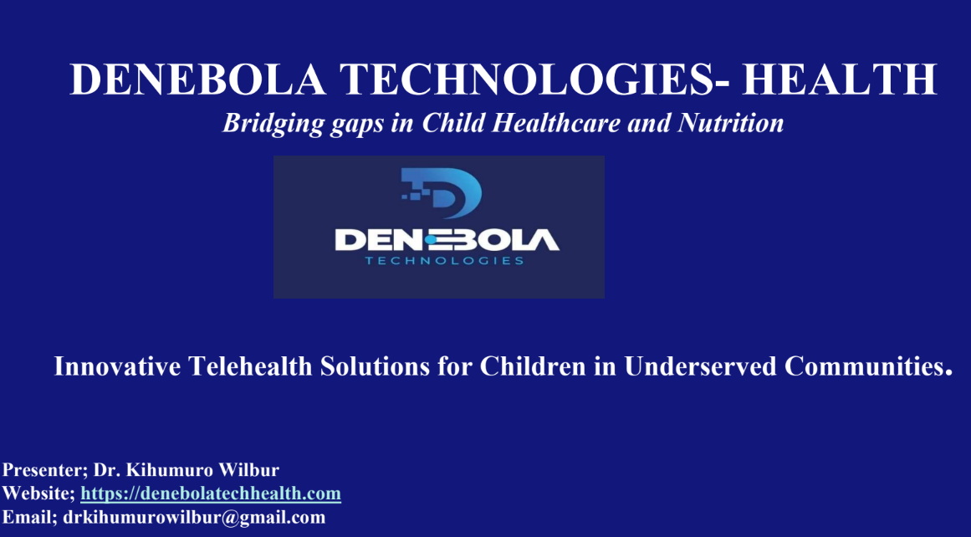
Photo: A screenshot with the overview of Denebola Technologies. Friday, December 8, 2023. Photo credit: Denebola Technologies
Denebola Technologies was founded by Dr. Kihumuro Wilbur John, a medical professional with a Bachelor's degree in Medicine and Surgery, in 2021. The company operates as a for-profit business entity in Uganda, with a focus on providing timely and affordable access to specialist doctors for children in underserved communities through its innovative hub-and-spoke telehealth model. This model connects pediatric patients in remote health facilities to specialist doctors using an AI-assisted chatbot telehealth technology software platform integrated with remote telehealth diagnostic medical devices. This approach ensures virtual consultations and examinations, offering expert care for children in regions facing healthcare disparities.
The advanced AI-assisted chatbot telehealth technology ensures real-time communication, allowing remote healthcare professionals to collaborate seamlessly with specialists. This collaboration results in precise diagnoses and personalized treatment plans for each child.
The company's mission is to break down barriers to healthcare access and bring quality medical services directly to those in need. They charge a fee per consultation through the “buy now, pay later” B2B model.
Fundraising ask: $10,000
Allocation: To massively market the healthcare services in UG, and TZ and make a system upgrade.

Questions from judges
Q: What is your definition of ‘health facility?’ What kind are you working with?
A: We are working with private local health facilities. Small clinics in the village cannot afford specialists. So, the model helps connect these small health facilities to specialists and digital devices for diagnosis when they are unable to make diagnoses firsthand. The model can be integrated into the national health system and specialists can see patients remotely.
Q: Have you presented this to the Ministry of Health, and what has been their feedback?
A: We discussed with the Uganda Medical Council to register our enterprise, but the concept is not yet well understood. They want physical premises whereas we are based online. However, we are using licensed pediatricians. We are now trying to get proof of concept to show that it can benefit the whole nation.
Q: Most patients in rural communities use government facilities. Are we missing out on a large chunk?
A: In my experience, people visit nearby clinics because government hospitals are overcrowded. However, the goal is to reach the government health facilities in the future.
Q: What’s your strategy for increased acceptance and uptake of the solution by government and other stakeholders?
A: We use licensed doctors, and their credentials are displayed to increase confidence. We seek funding to build a more robust system. We update our system every three months to accommodate more numbers.
Q: Are you making money?
A: We are making money. We charge per consultation. We made close to $70,000 in the past three years that we have existed.
Q: How is data being safeguarded?
The data is on the servers and secured from hackers and other issues. As we get more money, we use it to build a more robust system. All patient data is stored in country. A patient can get their data at any time. Their medical history is stored and can be accessed by medical professionals when they need it.
- Ddokolo Distributors Atom Uganda Limited
Photo: Ddokolo Suppliers founders Winfred Nannungi and Solomon Walusimbi make a business pitch. Friday, December 8, 2023. Photo credit: U-RIL
Ddokolo Distributors Atom Uganda Limited was founded in Wakiso, Uganda in 2021. The founders’ motivation stemmed from a collective vision to address challenges within the local fishing community among which malnutrition of HIV-AIDS affected people and children under five.
Ddokolo Distributors specializes in adding value to silverfish (known locally as "mukene"), producing snack, powdered, and salted sun-dried silverfish. The founders, both with backgrounds in nursing, recognized the nutritional benefits of silverfish and aimed to combat malnutrition prevalent among children.
The company's impact extends beyond the nutritional realm. Ddokolo Distributors creates employment opportunities, particularly for single mothers and youth, and provides hands-on skills training in areas such as fashion, design, pottery, and crafts. Furthermore, the business has contributed to community development by establishing a primary and vocational school.
Funding ask: $10,000
Allocation: Purchasing solar drying equipment for the rainy season, completing the factory to meet UNBS standards, rebranding and packaging, and scaling the business to meet the high demand.

Questions and answers from judges
Q: How can a customer distinguish Dddokolo silverfish from one that has not been properly cleaned?
A: We are in the process of relabeling our products to indicate their quality. However, proof of quality is that our product is stocked in high-end supermarkets, building market confidence. We also hold workshops with stakeholders to show them our process.
Q: How will you increase the scope of the target market (malnourished children)?
A: We use radio advertising, speak at functions, visit hospitals and antenatal clinics and create awareness about the nutritional values of “Mukene”. We are only limited by capital to increase our production.
Q: Are you making money?
Yes, we are. The company is well-known all over the country.

- Medical Street
Photo: Medical Street's John Okonye makes a business pitch. Friday, December 6, 2023. Photo credit: U-RIL
Founded in 2018, Medical Street's mission is to design, develop, manufacture, and market high-quality medical products. The company addresses the lack of access to child health measurement tools by producing BMI wheels, mid-upper arm circumference tapes, and height boards. A significant portion of rural healthcare centers lack these essential tools, impacting child health monitoring.
Medical Street offers locally produced, cost-effective, and easily accessible products. The tools are durable, featuring laminated designs, ensuring prolonged use for about six months.
The company aims to reduce the incidence of malnutrition and alleviate the overall burden, with a target of reaching an additional 1 million children in the next three years through product adoption in 200 healthcare facilities.
Medical Street's revenue model is based on product sales, complemented by training services.
Funding ask: $10,000
Allocation: To produce more tools, capitalizing on an existing market demand.

Questions from judges
Q: Are you making money?
A: Yes. We have customers from several healthcare facilities. The cost of production is UGX. 2,000 and we sell them at UGX. 5000.
Q: How are you countering competition and avoiding copycats?
A: We have a unique design by laminating them. We’ve also gained customer confidence by supplying genuine products.
Q: Which materials are you using? What’s your current reach?
A: Not so many sales thus far, but the market is there. We use plastics for our products. The plastics are imported.
Q: Do you sell to public facilities?
A: No, but it is our target market. But right now, we are working with private facilities.
Q: How will you penetrate the public market?
A: By gaining complete buy-in from the Ministry of Health, who have already provided positive feedback on our products. MoH suggested improvements that we made, and we are yet to go back and get approval.
Q: Which level of healthcare centers are you working with? Don’t they already have these products?
A: We work with small health centers. These products are available on the market but ours are cheaper and last longer.

- MobiKlinic
Photo: MobiKlinic's Andrew Ddembe and Aaron Ssempa make a business pitch. Friday, December 8, 2023. Photo credit: U-RIL
Founded in 2020, MobiKlinic Holdings Limited operates MobiKlearn, an e-learning platform empowering parents, caretakers, and teachers with health education focused on children. Priced at $6 per course, Mobiklearn offers flexible, convenient, and high-quality learning solutions, providing certification from Clarke International University.
MobiKlinic addresses Uganda's health challenges by emphasizing preventive health practices through education. Mobiklearn contributes to reducing child mortality by equipping parents and caretakers with essential knowledge to create a well-informed support system for children's health and well-being. Courses cover newborn care, nutrition, first aid, and danger signs in children, empowering caregivers to provide proper care.
MobiKlearn provides certificates to users upon course completion and allows subscription at $60, with bulk purchases available for organizations at $66 for a full course.
Affiliated with Clarke International University and partnered with UNICEF and Tech Hub, MobiKlearn plans to translate content into local languages, targeting the East African region with a market potential of 30 million over the next decade. The scaling model emphasizes accessible and customizable content everywhere.
Funding ask: $10,000
Allocation: To support its expansion efforts and enhance accessibility to child-focused health education.
Questions from judges
Q: What is the value proposition to the user? Why would someone who is not trying to be a health worker pay for the courses?
A: Community healthcare workers are certified through our platform. They can commercialize their skill and earn a living. People can obtain the knowledge for personal use. E.g., training in first aid.
Q: There is a plethora of free resources. What’s your USP?
A: MobiKlinic is a one-stop center and we have partnered with CIU for quality control and proof of having obtained the knowledge.
Q: What is the current uptake? What is the pricing basis?
A: We did a feasibility study and decided on the price based on that. We are confident that $6 is affordable. For rural areas, B2B helps reduce the cost. The B2B model has paid off much more. It’s too early to judge the B2C.
Q: Is the content aligned with national guidelines for newborn care?
A: Yes. It’s premised on the MoH manual. E.g., essential medicines course covers OTC drugs. We also have National Information Technology Authority certification.
Q: Do you update your courses according to guidelines?
A: Yes.
Q: Do you have videos that educate people about how to manage conditions, e.g., pneumonia?
A: Yes. However, we need funding for content development, based on feedback from healthcare providers.
Q: Do you provide mobile phones for child healthcare workers?
A: No. but our B2B partners do.
Q: What is your scope? How will you beat the competition, especially those supported by MoH?
A: We held discussions with the MoH digital committee. There isn’t an organization doing similar work to ours. The Mobiklearn system is designed to be integrated into the national system.

- PRUM Ventures
Photo: Prum Ventures' Walter Dunga (left) during the business pitch. Friday, December 8, 2023. Photo credit: U-RIL
PRUM VENTURES (U) LTD was founded in Kitagwenda, Uganda, in 2021. It is a registered for-profit business entity with a focus on child-centric products that aim to improve nutrition in pregnant women, mothers, and children below the age of 12.
Prum Ventures offers a range of innovative okra-based products to combat malnutrition, including whole meal okra porridge mix flour, okra tea, and okra powder, all designed to supplement diets with essential vitamins, folate, iron, protein, and carbohydrates. The company emphasizes the numerous health benefits of okra, such as its contribution to the physical and mental development of children.
Thus far, they have sold over 900kgs of Okra and enjoy a profit margin of 60%. Prum Ventures has several employees include 10 women. The company partners with RIL to gather evidence on how to reach its target market. They have also exhibited at national and international platforms.
Prum Ventures estimates its total addressable market at about $32.4 million, with plans to reach approximately 7.2 million individuals within three years through partnerships, online selling, and health campaigns.
Funding ask: USD 10,000
Allocation: Reduce operation costs, increase machinery, support marketing and advertising, and support business operations such as scaling up.
Questions and answers
Q: What’s your distribution network and your market reach?
A: There is an outlet in Kampala city center. We are waiting for certification from UNBS. We hope to start marketing in the city center by January 2024. We work with main distributors who have retail outlets to manage the costs of distribution. Materials are locally available, and we experienced at least 180% growth in one year.
Q: What have you done for product acceptability?
We did research, looking at the patterns of consumption in different parts of the country. For instance, the demand for sauce powder is higher in some parts of the country while in other parts of the country, they prefer tea. E.g., in Teso region, they prefer to eat it. So, our products are tailored to the interests of our target customers.

- SMILE Nutraceuticals
Photo: SMILE Nutraceutical's Mukalazi makes a business pitch. Friday, December 8, 2023. Photo credit: U-RIL
Mukalazi Jamilu founded Smile Nutraceuticals Limited in Kampala, Uganda, in 2022. The for-profit business entity is legally registered and operates locally, focusing on products dedicated to improving the lives of children in Uganda.
One of their flagship products is Smile Mosquito Repellent Jelly, a unique formulation crafted with natural ingredients like Citronella, Mint, Eucalyptus, Neem, and Shea Butter. This repellent provides over 8 hours of protection against mosquito bites while also serving as a skincare solution, treating and preventing skin complications.
This product aims to help eradicate child morbidity, cognitive function disorders, and death due to malaria by preventing mosquito bites. With more family income diverted away from the treatment of malaria, families have a better chance of providing nutrition for their children.
The target market for Smile mosquito repellent includes parents, caregivers, schools, education institutions, healthcare providers, clinics, local retailers, and pharmacies. The company aims to reach households in regions prone to malaria infections, emphasizing the importance of using natural repellents for malaria control in children.
Funding ask: $10,000
Allocation: Reaching the most affected through social marketing.

Questions from judges
Q: There are several mosquito repellents. What are you doing to grow in a competitive market?
A: Most products are imported, they are not organic, and cannot be applied to the skin since they are toxic. Smile mosquito repellent is completely organic and can be used to moisturise the skin.
Q: Have you received any reports on allergic reactions?
A: We have been monitoring it. The allergic ingredients are eliminated. We include ingredients on the tin, just in case anyone may be allergic.
Q: What is the cost of production vs the sale?
A: The 70g tin costs UGX. 800 to make and is sold at UGX. 1500. The 140g tin costs UGX. 1300 to make and we sell it at UGX. 3000. The 300g tin costs UGX. 3000 and is sold at UGX. 5000. So, the products are affordable. The mosquito repellent is approved by UNBS.

- WaterKit
Photo: WaterKit founder Denis Ogwang (right) makes a business pitch. Friday, December 8, 2023. Photo credit: U-RIL
WaterKit, established in 2021, is a for-profit business operating in Uganda. The business is legally registered, with operations based in Lira.
WaterKit's primary product is the WaterKit Wallet, a mobile money-powered digital wallet providing zero-interest credit for essential water, sanitation, and clean energy products and services. The wallet encourages community contributions and allows for direct donations for WASH products, aiming to create a revolving fund and increase access to essential products. The innovative solution addresses the challenge of frequent breakdowns of boreholes and the lack of sustainable financing for children in Uganda. Diarrhea, a leading cause of death for children under five, remains a critical concern, with approximately 33 child deaths annually.
WaterKit offers a range of products and services, including water treatment products, water filters, and others. WaterKit's mission is to improve community health and livelihood through increased access to affordable WASH and clean energy products and services. By providing access to clean water, basic sanitation, and hygiene services, the business directly benefits children by reducing the risk of water-borne diseases such as diarrhea, dysentery, and cholera.
The company’s scaling strategy includes expanding operations and product offerings. A pilot in Bidibidi refugee camp is scheduled for 2024, with further scaling to other refugee communities in 2025.
Profits generated are reinvested to continue creating impact, aiming for self-sustainability beyond grants.
Funding ask: $10,000
Allocation: Business expansion

Questions from judges
Q: With zero percent interest credits, how do you cover the transfer fees?
A: The credit is not money. It’s products and services, that are paid for through mobile money. We factor in the cost of delivering the products.
Q: Do you do construction?
A: It’s currently out of our financial scope, but we hope to do that in the future.
Q: How are you working with water and sanitation committees?
A: We are following MWE guidelines, and working with the water and sanitation committees directly. Chairpersons collect money and bank on our platform.
Q: What additional services do you provide and what are the costs?
A: Repair and maintenance services, and quality spare parts.

- Youth for Life Tree Planting
Photo: Youth for Life's Denis Okwir during his business pitch. Friday, December 1, 2023. Photo credit: U-RIL
When Okwir Denis lost his sister, leaving behind a months-old baby, he was faced with the challenges of feeding the infant. The transformative power of nutritious porridge became evident as the baby not only lived but thrived. This profound experience inspired the establishment of Youth For Life Tree Planting Ltd and its flagship product- Damila children’s porridge in Lira District, Uganda in 2016. As a for-profit business entity, the company is legally registered and operates locally, with a commitment to children’s health and nutrition.
Damila children’s porridge is made from locally sourced, high-protein flour containing highly nutritious foods such as maize, silverfish, soya bean, and simsim. Youth for Life Tree Planting Ltd operates under the concept of a Village Seed Bank to promote the health and well-being of children and support local sustainability. Their mission is to improve the health and nutrition of children all over Uganda.
Funding ask: $8750
Allocation: Product certification with UNBS, buying machinery, and market expansion.

Questions from judges
Q: How will you reach all regions in Uganda?
A: Automating production using machines will help increase production. We currently use YY courier services to reach our market.
Q: What is the sale price vs cost to produce? And who is the typical customer?
The production cost is UGX. 2500 for 500g, while the selling price is UGX. 5000. We give products to farmers on credit and they pay back with raw materials.
Q: What’s your production capacity?
A: It’s 500 kilos per day.

Successful applicants of the recoverable grant business pitch
Judges made deliberations and announced five successful applicants:
- Botanica Repellent
- Ddokolo Distributors Atom Uganda Ltd
- Prum Ventures
- WaterKit
- Youth for Life Tree Planting Ltd

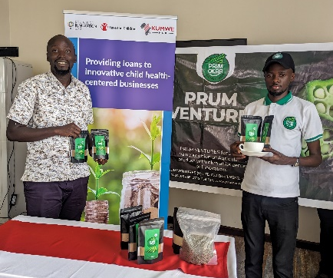
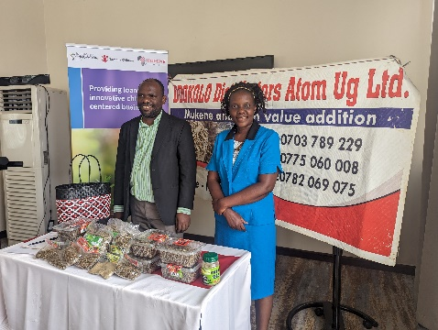
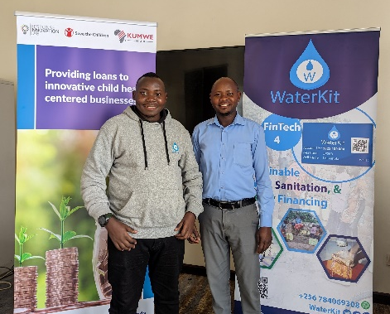
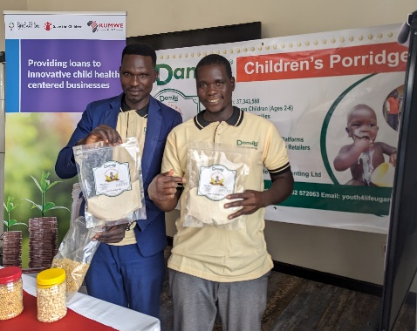
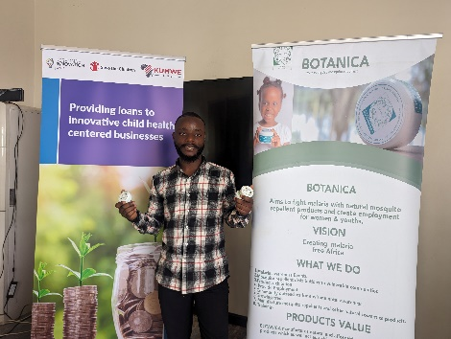

Photo collage: Successful applicants pose for photos. Friday, December 8, 2023. Photo credit: U-RIL

U-RIL will conduct due diligence in early 2024 ahead of recoverable grant provision to the successful applicants.

