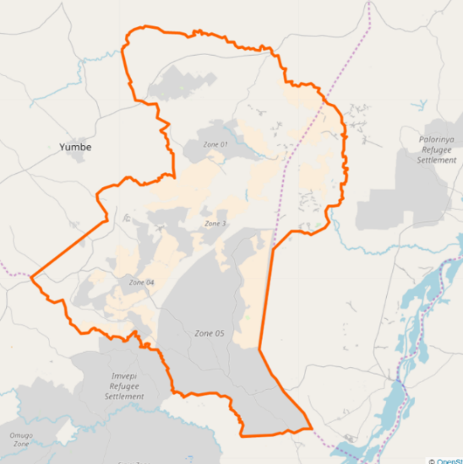
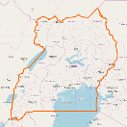
Bidi Bidi Settlement
Bidi Bidi is located in the West Nile region of northern Uganda.
Bidi Bidi is the largest refugee settlement in Uganda, and second largest in the world. Located in northwestern Yumbe District, the settlement covers an area of 250 km², over several zones.

Fueled by conflict in South Sudan, 95% [1] of Bidi Bidi’s over 287,000 refugees have arrived over the past two years. With a host population of nearly 585,000, the refugee influx into Yumbe District has placed significant pressure on natural resources, but also presents new local business opportunities serving the refugee population. [2]

This market profile seeks to inform businesses and entrepreneurs of the opportunities and challenges of operating in Yumbe District. The references cited here can serve as resources for further market analysis.

Livelihoods
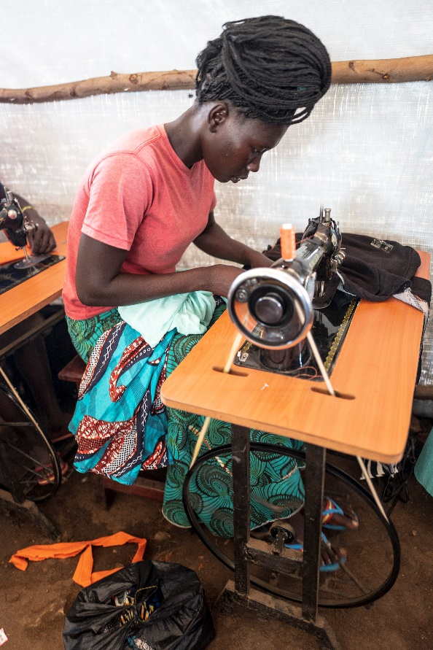  A woman takes part in livelihoods training  (credit: © UNHCR/Charlotte Allan) | Refugee employment: In West Nile, 12% of refugees are unemployed (but looking for work), while a further 67% are out of the labor force entirely. [1]  Top sources of household cash [1]:  - Sale of food rations  ~30%  each  4-6%  each  1-3%  each  - None  - Petty trade  - Sale of cooking fuel  - Sale of fruit/veg  - Sale of cereals  - Agricultural wages  - Casual labor  - Humanitarian aid  Business activity in Bidi Bidi  - 13% of businesses are market vendors, including food, drugs and clothing. [3]  - Of the 500 active food traders, 80% are owned by host community members. [4]  - Agricultural processing is owned by 16 registered grain milling operations, with 40 total milling machines. [4]  - Other active businesses include soap making, restaurants, and bars. [3]

Income and Expense
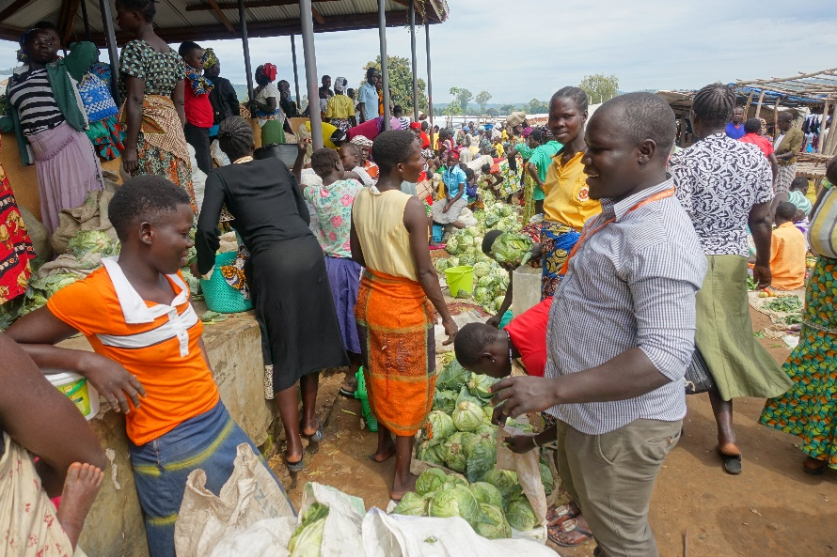  A market in Bidi Bidi settlement (credit: World Vision) | Annual income for refugee households (UGX) [5]
In purchasing power parity terms, the international poverty line is set to around UGX 2,300. [1]  - Refugee expenditure: 91% live on less than UGX 2,000 per day. [1]  24% of host community nationals in West Nile live below the poverty line.  - Host expenditure: averages UGX 2,200 per day, per capita. [1] |  | Refugee income: 48% of households earn less than UGX 500k per year. 86% earn less than UGX 2 MM per year. [5]

Education and Skills
Among young refugees in Bidi Bidi, demand is high for vocation training programs in the areas of computer skills, catering and hair dressing, while more traditional vocations such as carpentry and brick laying are less attractive. [5]

Indicators of educational attainment, literacy, and agricultural skills. Data for South Sudan is used as a proxy for Bidi Bidi’s refugee population. [3] [12] [8] [13]

Agriculture
Compared to other refugee settlements in Uganda, Bidi Bidi has a low level of reliance on agriculture. This is possibly because, being recently established, refugee farmers have not had sufficient time to develop their land. [6]

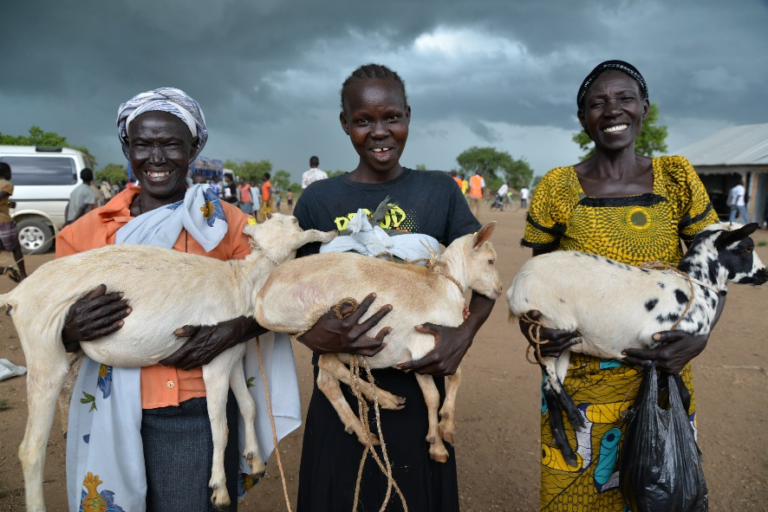
- Only 1.8% of refugees are engaged in agriculture, significantly lower than nearly all other settlements in Uganda. [5]
Refugee women proudly show off their goats
(credit: World Vision)
- The most important crops in Bidi Bidi are sorghum, maize, and simsim, while key crops for other settlements, such as Casava, are practically absent. [6]
- Refugees raise goats and chickens, but not larger livestock like cows or pigs. [6]
- The official allocated plot size for refugees in Bidi Bidi is 900 m², but is only intended for shelter. [5]

Energy
Grid access
Uganda’s Rural Electrification Agency (REA) is currently undertaking grid extension into the northern part of Bidi Bidi. In coordination with REA, Power Africa has identified a potential mini-grid site in an eastern part of the settlement that will not be covered by grid extension. [7]

REA grid expansion
- Villages: Base camp, villages in south and east
- Approximate households. 1,300
Potential mini-grid site
- Villages: Bidi Bidi, Kiri
- Approximate households: 525

The West Nile region, overall, has an electrification rate of around 8%. [8]

Cooking
Fuels and stoves in use by refugees [10]
- Fuelwood consumption:
3.5 kg per day per capita [10]
- Fuel expenditure: UGX 32,500 per month [11]

Fuels in use by hosts [8]

Internet and Mobile
Public connectivity [9]  Observed access  - Spotty MNO coverage creates a “patchwork of quality” that varies from operator to operator across the settlement.  - Zones 1 and 2 report better service; there is a significant drop from 3G->2G service observed in Zones 3-5.  - Disparity observed between connection speeds in host communities and settlement Zones 1 and 2.  Phone ownership [3]  - 73% of men; 44% of women | NGO connectivity [9]  Perceived quality  - Significantly improved service has recently been reported by NetHope member NGOs who have begun using Airtel microwave links offered through the NetHope Bandwidth Demand Aggregation program.  NGO access modes  - VSATs  - WiMAX  - Mobile hotspot  NGO access costs  - Reported at ~$200/Mbps/month for a microwave link
Mobile money [3]  - 80% of population live within 1km of a mobile money agent.  - 60% of mobile money agents report an average monthly commission of between UGX 100k – 300k.  - 28% of mobile money agents reported network outages as their largest challenge.  - 40% of cash-in transactions are between UXG 200k – 400k.  - 33% of businesses use mobile money. |  | Mobile networks [9]  - Airtel – 3G  - MTN – 3G  - Africel

References

[1] | WFP, "Analysis of Refugee Vulnerability in Uganda and Recommendations for Improved Targeting of Food Assistance," 2018.
[2] | UNHCR, "Uganda Refugee Response Portal," [Online]. Available: https://ugandarefugees.org/. [Accessed 17 June 2018].
[3] | UNCDF, "Digital Financial Service Ecosystems in Bidi Bidi Refugee Settlement," 2018.
[4] | WFP, "Market Assessment in Refugee Areas 2016-2017," 2016.
[5] | UNHCR, "Livelihoods Socio-Economic Assessment in the Refugee Hosting Districts," 2017.
[6] | UNHCR, "Market Systems Development," 2018.
[7] | Power Africa.
[8] | USAID, "DHS Survey," 2016. [Online]. Available: https://www.statcompiler.com/.
[9] | NetHope.
[10] | FAO, "Rapid Woodfuel Assessment 2017 Baseline Assessment for the Bidibidi Settlement, Uganda," 2017.
[11] | UNHCR, "Energy needs assessment report for refugee settlements in Uganda," 2018.
[12] | Knoema, "World Data Atlas," [Online]. Available: https://knoema.com/atlas/.
[13] | UNDP, "Briefing note for countries on the 2018 Statistical Update: South Sudan," 2018.

