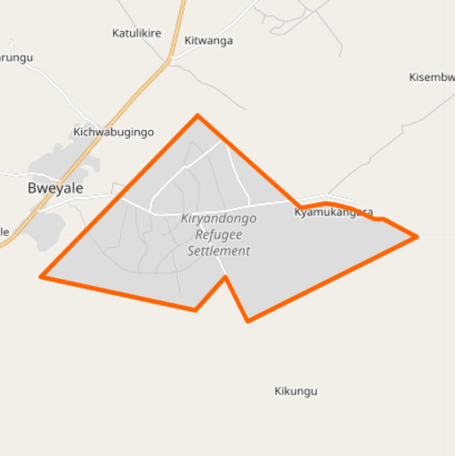
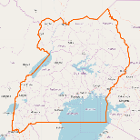
Kiryandongo Settlement
Kiryandongo is located in Bunyoro region, northwestern Uganda.
Kiryandongo refugee settlement hosts a diverse demographic group, spanning a range of ethnicities, countries of origin, time spent in Uganda, and income levels, including: South Sudanese, Kenyan and internally displaced Ugandans.

The settlement population is around 57,000, with a total population of 277,000 for the host Kiryandongo District. [1] In addition to new arrivals from South Sudan, Kiryandongo’s host communities attract well-off refugees from other parts of Uganda, due to its diverse ethnic makeup. [2]

This market profile seeks to inform businesses and entrepreneurs of the opportunities and challenges of operating in Kiryandongo District. The references cited here can serve as resources for further market analysis.

Livelihoods [3]
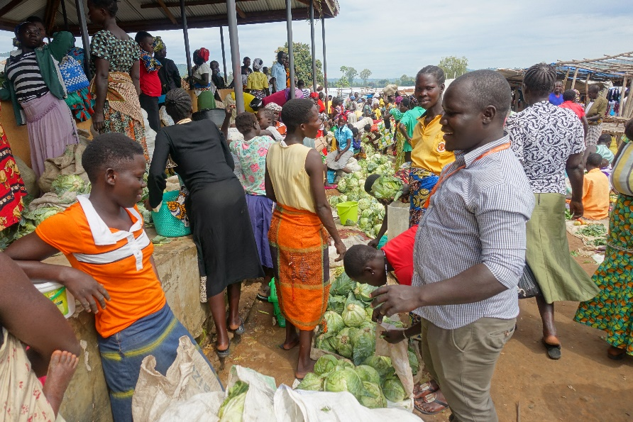  Photo caption (credit:) | Refugee employment: 31% of refugees farm their own land; 28% are self-employed, and 37% are unemployed or out of the labor force [3]  Top sources of household cash [3]  – ~33%  3-6%  each  1-2%  each  – 15%  – ~23%  - None  - Agricultural wages  - Sale of cereals  - Other  - Sale of food rations  - Casual labor  - Humanitarian aid  - Self employed  - Sale of cooking fuel  - Sale of fruit/veg
Business activity: [3]
- Kiryandongo’s main market is at Bweyale, with over 600 traders in operation, including refugees and host communities members, servicing an average of 60,000 customers each week.

Income and Expense
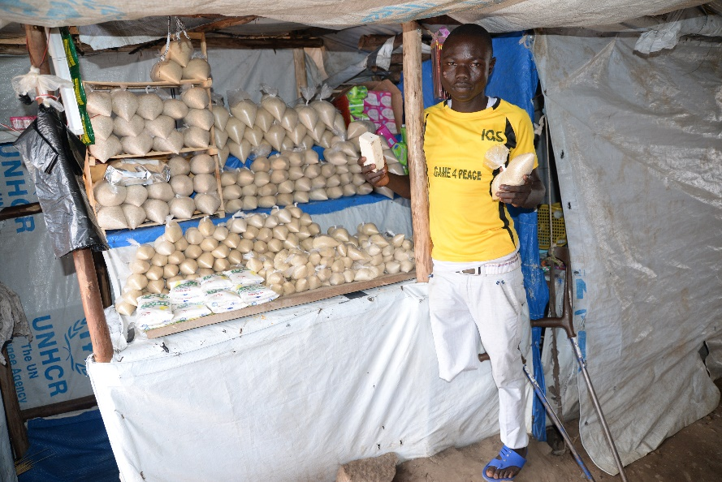  Photo caption (credit:) | Annual income for refugee households (UGX) [4]
Refugee expenditure: [3]  - 54% live on less than UGX 2,000 per day.  - In purchasing power parity terms, the international poverty line is set to around UGX 2,300. |  | Refugee income: 55% of households earn less than UGX 500k per year. 76% earn less than UGX 2 MM per year. [4]

Agriculture
The official allocated plot size for refugees in Kiryandongo is 2,500 m². Refugees may also rent land from host community members. [4]
Many households plant at least one seasonal crop and sell some portion of their produce to market. [5]

- A 2017 survey showed that only around 17% of refugees have a land plot of 2,500 m² or greater. [5]
- Approximately 47% of refugees reported having a plot of land of less than 500m². [5]

Education and Skills
Indicators of educational attainment and agricultural skills. Host data is in reference to Bunyoro Region [8], while refugee data is from Kiryandongo settlement. [5] [2]

Energy [6]
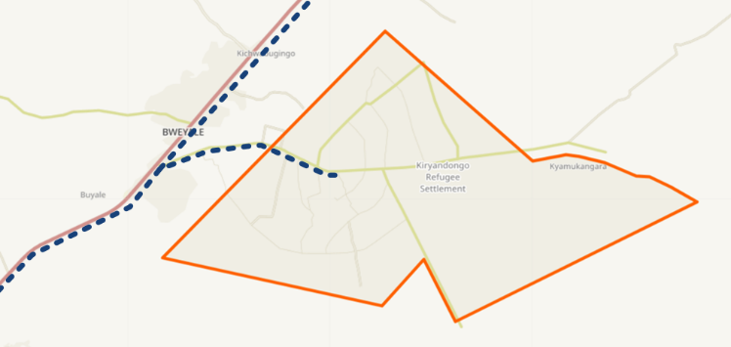
While both MKOPA and Solar Now are active in the vicinity of Kiryandongo, though most refugee households and businesses do not use solar kits.
The national grid electrifies base camp and continues for approximately 2-4 km into the settlement, but does not connect many structures.

National Grid
- Refugees use kerosene (approximately UGX 1,000/week) and torches for lighting.
- The most desirable appliances for households are lighting and phone charging, followed by TV and refrigerators.
- Businesses with diesel generation pay UGX 35,000/liter at Bweyale market, plus an additional UGX 3,000 for transport each way.
- The most desirable equipment for businesses and farmers are lighting and refrigeration, followed by freezers.

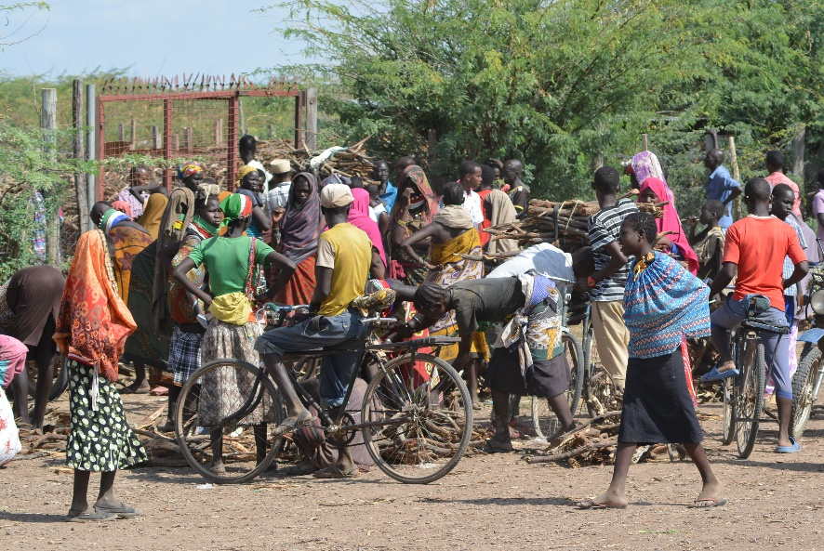  Photo caption (credit:) | Narrative

Internet and Mobile
Public connectivity [7]  Observed access  - Community Technology Access (CTA) centers in use in the settlement.  - No IT use in health facilities.  - No fixed internet services in town; host community members sometimes use CTAs for internet access.  Phone ownership  - 74% of refugee households have at least one mobile phone. [5]  - The cost to charge a mobile phone is UGX 500. [6] | NGO connectivity [7]  Perceived quality  - Varied but generally problematic.  - Congested/poor quality network connectivity.  - NGOs “churn” between carriers based on frustration with service quality.  - VSAT connections slow and unreliable.  NGO access modes  - VSATs  - Mobile hotspot  NGO access costs  - Range from $128-$200/Mbps/month
Mobile money  - Mobile money use tends to vary depending on a refugee’s time in country, with half to two-thirds of established refugees using mobile money compared to about a quarter of new arrivals. [6] |  | Mobile networks [7]  - Airtel – 2G  - MTN – 2G/3G  - Africel – 2G

References

[1] | UNHCR, "Uganda Refugee Response Portal," [Online]. Available: https://ugandarefugees.org/. [Accessed 17 June 2018].
[2] | Uganda Investment Authority, "Kiryandongo District Investment Profile," 2017.
[3] | WFP, "Analysis of Refugee Vulnerability in Uganda and Recommendations for Improved Targeting of Food Assistance," 2018.
[4] | UNHCR, "Livelihoods Socio-Economic Assessment in the Refugee Hosting Districts," 2017.
[5] | European Union, "Conflict Analysis Assessment," 2017.
[6] | Power Africa.
[7] | NetHope.
[8] | USAID, "DHS Survey," 2016. [Online]. Available: https://www.statcompiler.com/.

